**Rustic Masonry Dove White Brick Effect Tiles:** 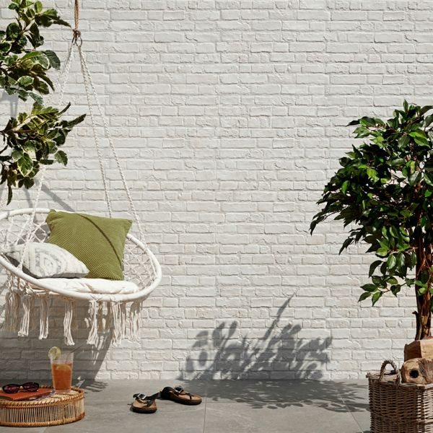

## **Product Description**

Create some rustic industrial charm in your home this season with these Dove White Painted Brick Effect Tiles. They have a realistic brick effect design; ideal for injecting an industrial or farmhouse look into a bathroom, kitchen, living area or bedroom. They have a textured, staggered design, to help capture the likeness of a rustic rural wall.

What's special about these tiles?

> White-washed brick effect

> Matt finish

> Durable porcelain body

> Textured look, perfect for wall design and casting intricate shadows

> 15 different variations for a realistic finish

Try before you buy

If you'd like to take a closer look, why not order a sample tile? Samples are a great way to get a feel for a tile's true colour and texture, and you can see how it looks in your chosen room!

## **Product INFO**

* Product ID: 15209
* Tiles Per SQM: 5.7603686635945
* Sale by: Per SQM
* Size: 310x560x10mm
* Weight: 3.85 KG
* Material Type: Porcelain
* Finish: Matt
* Colour: White
* Suitability: Walls
* Grade: 4
* Rectified Edge: No
* Underfloor Heating: No
* Thickness (mm): 10